# A

**Synopsis Report**

On

ECG Analysis

For

partial fulfillment of award of the

1. **Tech Degree in Computer Science**

**And Engineering**

# Under the Supervision of

**Dr. Ashish Tripathi**



### Submitted by:

Radha Verma(1901920100209)

### Session: 2021-22

**G. L. Bajaj Institute of Technology and Management, Greater Noida**

# TABLE OF CONTENTS

1. Introduction
2. Literature Review
3. Materials and Methods
4. Proposed architecture
5. Deep Learning Training Process
6. Result Analysis
7. Conclusion

## INTRODUCTION

Heartbeat related diseases are the major cause of death across the world [1] and the ELECTROCARDIOGRAM (ECG) is the primary tool for their diagnoses.

ELECTROCARDIOGRAM (ECG) is a way to track a person’s heart activity through electrical signals. ECG test can be reliably used to record the imbalance in the heartbeat. The main task in the ECG test is to detect and categorize different waveforms in the signal.

Issue with doing ECG Analysis manually is that it is both time-taking and prone to errors. As Electrocardiograms is moving from analog to digital, artificial intelligence-based analysis of electrocardiograms is gaining importance. But the limited performance of the classical algorithms is stopping them to be used as a standalone tool for ECG diagnosis in clinical practice. They have limited performance in practice because of the inter-patient variations of the Electrocardiogram signals. So, they generally show a common downside of having an inaccurate and inconsistent performance upon classifying any new patient’s ECG signal. As the abnormal heartbeat cases cause around 1/3rd of the total deaths in the world, the analysis of ECG data should be highly accurate and consistent.

The primary motive of the suggested method is to develop a convolutional neural network architecture with good accuracy to classify the heartbeat into one of the five different kinds of arrhythmias based on the ECG signal of the patient.

The proposed method is being able to make predictions with an average training accuracy of 99.23% and an average validation accuracy of 98.19% on the MIT-BIH Arrhythmia Dataset.

1. **LITERATURE REVIEW:**

[Liu, Huang, Chang, Wang, and He (2018) [1]](https://www.sciencedirect.com/science/article/pii/S2590188520300123" \l "bib0062) suggested a multiple-feature-branch Convolutional Neural Network (MFB-CNN) for automated myocardial (MI) detection and localization using ECG. For patient-specific experiment, the average accuracies of MI detection and localization are 98.79% and 94.82%, respectively. Another best consequence is [Al Rahhal,](https://www.sciencedirect.com/science/article/pii/S2590188520300123" \l "bib0008)

[Bazi, Al Zuair, Othman, and BenJdira (2018) [2]](https://www.sciencedirect.com/science/article/pii/S2590188520300123" \l "bib0008) proposed a CNN for VEB, and SVEB classification. They utilized a continuous wavelet transform (CWT) and an 11-layer CNN. For SVEB, the average accuracy is 99.82% for INCART database and 98.4% for SVDB database. In a unique study combining elements from DL and ML, Tison *et al.*5 [3] trained a modified CNN architecture on a dataset utilizing publicly available and institutional data to automate ECG segment classification. For HCM, Ko *et al*. at the Mayo Clinic5 [4] report the use of a CNN to train 12-lead ECGs from ∼47K patients to diagnose HCM. Remarkably, their models achieved extremely high AUCs of 0.96 on the test set.

[Sayantan, Kien, and Kadambari (2018)](https://www.sciencedirect.com/science/article/pii/S2590188520300123" \l "bib0087) [5] proposed a feature representation using Gaussian- Bernoulli Deep Belief Network (GB-DBN), and a linear SVM classifier has been considered to train the models for the classification task.

[Wang et al. (2019) [6]](https://www.sciencedirect.com/science/article/pii/S2590188520300123" \l "bib0104) proposed a global and updatable classification scheme named Global Recurrent Neural Network (GRNN). The GRNN showed great fitting ability and high performance on the training set, with a minimum accuracy of 99.8% in VEB and SVEB detection.

Faust et al. (2018) [7] suggested a Deep Learning architecture consisting of RNN with LSTM to detect Atrial fibrillation beats. It achieved 98.51% accuracy.

## MATERIALS AND METHODS:

### Dataset:

* + The Dataset used to train the model for correctly classifying arrhythmia is the MIT-BIH Arrhythmia Dataset [8]. The dataset is in csv format.
  + It has 109446 rows, which is the number of training examples and 188 columns, out of which 1 column specifies the label and the rest 187 describe the features.
  + There are five classes: [N:0, S:1, V:2, F:3, Q:4]
  + N: Normal beats, S: Superventricular ectopic beats, V: Ventricular ectopic beats, F: Fusion beats and Q: Unknown beats.

### Data Augmentation:

After doing some visual analysis of the data, it was observed that there exists a huge imbalance in the dataset, with class 0 covering almost 80% of the data.

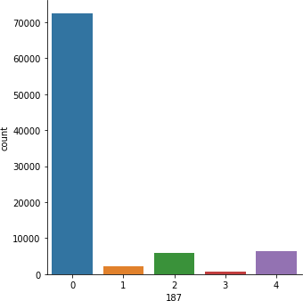

**Fig 1: Imbalanced Data**

To overcome this imbalance, the dataset has been resampled such that there are 100000 examples now in total with each class having an equal number of training examples, i.e. there are 20000 examples of each class.

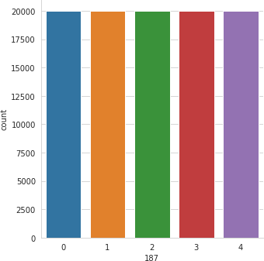

**Fig 2: Balanced Data**

## PROPOSED ARCHITECTURE:

* + The design is a CNN architecture with an input shape (187,1).
  + The first layer is a Convolutional layer. Then there are BatchNormalization layer and MaxPooling Layer.
  + The same sequence of the arrangement of layers is repeated three times with varying filter sizes. The primary objective of these layers is to extract features.
  + The resulting shape that comes out through the above layers is (23,64).
  + Then the data is flattened into a 1-d array and merged with a DNN model having a hidden layer with 512 nodes.
  + Softmax function with 5 units for 5 classes is used for activating the output layer.

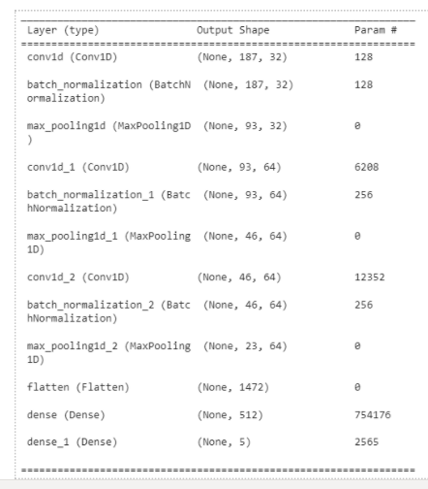

**Fig 3: Proposed Architecture**

## DEEP LEARNING TRAINING PROCESS:

The training process graph depicts that the network runs without much zigzags thus showing that the learning rate and optimizer chosen is optimum.

Since the training accuracy and the validation accuracy are very close, it can be deduced that the model does not overfit.

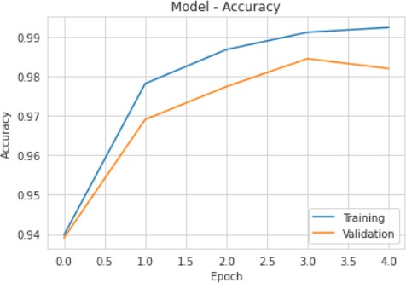

**Fig 4: Training Process**

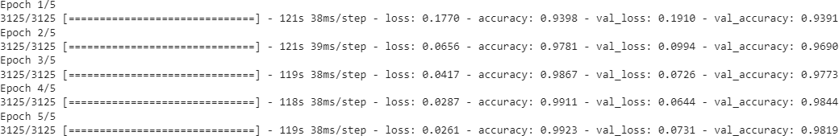

**Fig 5: Accuracies after each epoch**

## RESULT ANALYSIS:

After evaluating the arrhythmia classifier on 20000 images that the Model hadn't seen before we got a satisfactory result with a validation accuracy of 98.19 which is competitive to state of the art result.

The figure below depicts the confusion matrix when the testing dataset is fed to the model and we can clearly infer from the figure that the proposed architecture is being able to make predictions correctly and distinguish the classes differently.

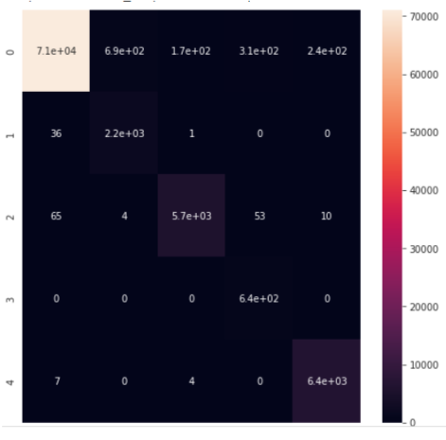

**Fig 6: Confusion Matrix**

|  |  |  |  |
| --- | --- | --- | --- |
| **Authors** | **Method Used** | **Dataset** | **Accuracy** |
| [Liu et al. (2018)](https://www.sciencedirect.com/science/article/pii/S2590188520300123" \l "bib0062) [9] | Feature Extraction: MFB-CNN  Classification: FCN | PTB | 99.95 |
| [Xia et al. (2018)[10]](https://www.sciencedirect.com/science/article/pii/S2590188520300123" \l "bib0110) | Feature Extraction:  Short Time Fourier Transform (STFT) Stationary Wavelet Transform (SWT)  Classification:  CNNs: DeepNet1 (STFT+CNNs) DeepNet2 (SWT+CNNs) | MITDB AFIB | 98.29 |
| [Wang et al. (2019)](https://www.sciencedirect.com/science/article/pii/S2590188520300123" \l "bib0104) [6] | Feature Extraction: Morphological and Premature- or-Escape-Flag (PEF)  Classification: GRNN | MITDB SVDB LTSTDB-I | 97.4 |
| [Sayantan et al.](https://www.sciencedirect.com/science/article/pii/S2590188520300123" \l "bib0087) [(2018)](https://www.sciencedirect.com/science/article/pii/S2590188520300123" \l "bib0087) [5] | Feature Extraction: GB-DBN Classification: SVM | MITDB SVDB | SVEB Accuracy: 99.5%, VEB  Accuracy: 99.4% SVDB: SVEB  Accuracy: 97.5%, VEB: Accuracy: 98.6% |

**Table 1: Comparative Analysis**

## CONCLUSION

In this work, a method has been suggested for classifying the heartbeat of people based on the ECG signal. Precisely, a deep CNN model has been trained for classifying arrhythmia. According to the accuracies obtained, it can be concluded that the network performs satisfactorily well and can be compared with the existing state of the art models.

## REFERENCES

1. W. Liu, Q. Huang, S. Chang, H. Wang, J. He. Multiple-feature-branch convolutional neural network for myocardial infarction diagnosis using electrocardiogram Biomedical Signal Processing and Control, 45 (2018), pp. 22-32
2. M.M. Al Rahhal, Y. Bazi, M. Al Zuair, E. Othman, B. BenJdira Convolutional neural networks for electrocardiogram classification Journal of Medical and Biological Engineering, 38 (6) (2018), pp. 1014-1025
3. Tison GH, Zhang J, Delling FN, Deo RC. Automated and interpretable patient ECG profiles for disease detection, tracking, and discovery. *Circ Cardiovasc Qual Outcomes* 2019;12:e005289. [[PMC free article]](https://www.ncbi.nlm.nih.gov/pmc/articles/PMC6951431/) [[PubMed](https://www.ncbi.nlm.nih.gov/pubmed/31525078)] [[Google Scholar]](https://scholar.google.com/scholar_lookup?journal=Circ%2BCardiovasc%2BQual%2BOutcomes&title=Automated%2Band%2Binterpretable%2Bpatient%2BECG%2Bprofiles%2Bfor%2Bdisease%2Bdetection%2C%2Btracking%2C%2Band%2Bdiscovery&volume=12&publication_year=2019&pages=e005289&pmid=31525078) [[Ref list]](https://www.ncbi.nlm.nih.gov/pmc/articles/PMC8350862/" \l "euaa377-B54)
4. Kwon J-M, Jeon K-H, Kim HM, Kim MJ, Lim SM, Kim K-H et al. Comparing the performance of artificial intelligence and conventional diagnosis criteria for detecting left ventricular hypertrophy using electrocardiography. *Europace* 2020;22:412–9. [[PubMed]](https://www.ncbi.nlm.nih.gov/pubmed/31800031) [[Google Scholar]](https://scholar.google.com/scholar_lookup?journal=Europace&title=Comparing%2Bthe%2Bperformance%2Bof%2Bartificial%2Bintelligence%2Band%2Bconventional%2Bdiagnosis%2Bcriteria%2Bfor%2Bdetecting%2Bleft%2Bventricular%2Bhypertrophy%2Busing%2Belectrocardiography&volume=22&publication_year=2020&pages=412-9&pmid=31800031) [[Ref list](https://www.ncbi.nlm.nih.gov/pmc/articles/PMC8350862/" \l "euaa377-B56)]
5. G. Sayantan, P. Kien, K. Kadambari Classification of ECG beats using deep belief network and active learning Medical & Biological Engineering & Computing, 56 (10) (2018), pp. 1887-1898
6. G. Wang, C. Zhang, Y. Liu, H. Yang, D. Fu, H. Wang, P. Zhang A global and updatable ECG beat classification system based on recurrent neural networks and active learning Information Sciences, 501 (2019), pp. 523-542
7. O. Faust, A. Shenfield, M. Kareem, T.R. San, H. Fujita, U.R. Acharya Automated detection of atrial fibrillation using long short-term memory network with RR interval signals Computers in Biology and Medicine, 102 (2018), pp. 327-335
8. <https://www.kaggle.com/shayanfazeli/heartbeat>
9. W. Liu, Q. Huang, S. Chang, H. Wang, J. He Multiple-feature-branch convolutional neural network for myocardial infarction diagnosis using electrocardiogram Biomedical Signal Processing and Control, 45 (2018), pp. 22-32
10. Y. Xia, N. Wulan, K. Wang, H. Zhang **Detecting atrial fibrillation by deep convolutional neural networks** Computers in Biology and Medicine, 93 (2018), pp. 84-92